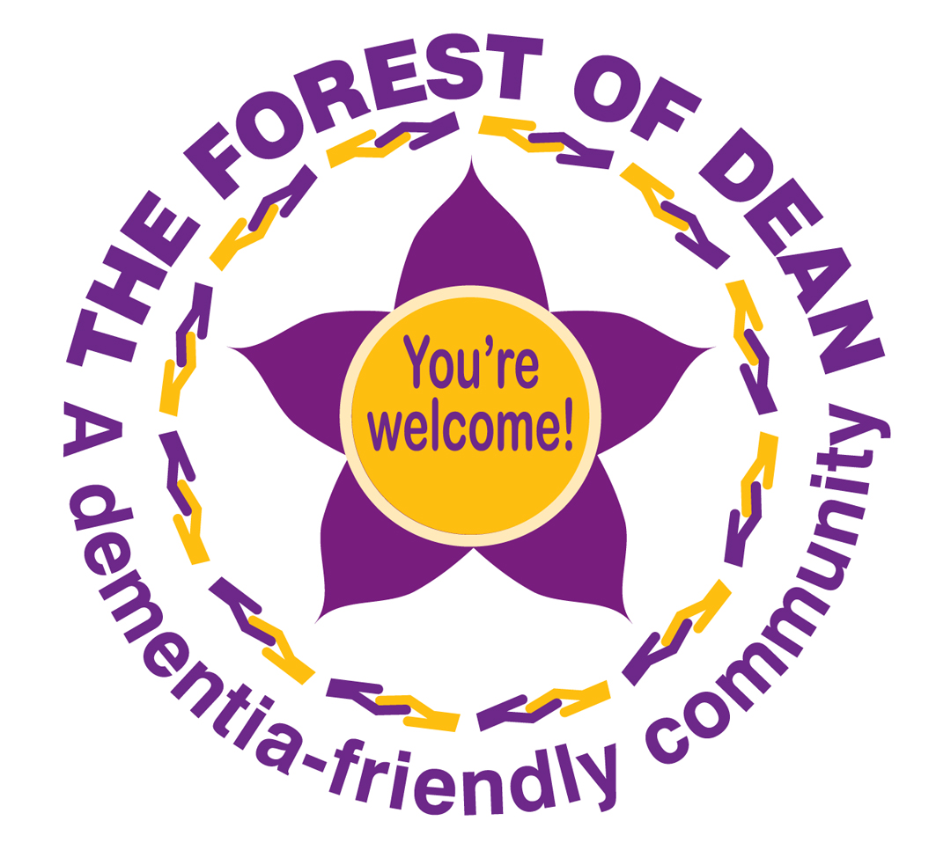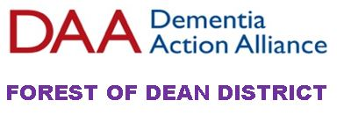

Local Membership Form

Becoming a member of the Forest of Dean Dementia Action Alliance is about becoming part of a network, a partnership of people across the district who are proactively trying to make dementia inclusive communities. Which by definition are welcoming communities for all. Our key objectives are to:
- Increase dementia awareness in the district
- Encourage and enable community activities to be more inclusive for people living with dementia and to support the development of activities that respond to the needs of people living with dementia.
- Encourage community buildings and spaces to be as accessible as possible.

Completing this membership form is a commitment to work together, it is about you becoming part of a supportive, proactive network where together we work to enable dementia inclusive communities.

Organisation / Name _________________________________________________

Contact Details

Contact name / role
Address

Phone
Email
Website

Can we share your contact details?
Yes ☐ No ☐ with other Forest of Dean Dementia Action Alliance members
Yes ☐ No ☐ the community

Tell us a bit about you, your group, organisation or business:

Our Action Plan is:
Please complete at least 3 actions that you will work towards….
Action 1: What we/I are going to do:

Action 2: What we/I are going to do:

Action 3: What we/I are going to do:

Are there any challenges you can think of to delivering these outcomes for you or your organisation/group/business?

We host monthly online “catch ups” and organise periodic catch ups in person – this is an opportunity to share challenges, discuss ideas and support each other.
Yes ☐ No ☐ we would like to be included on the distribution list for the catch up meetings.

Please do not hesitate to contact us for information or support

Please email your organisation logo (in either pdf or jpg format) & return this form to: mailto:dementiaactionalliance@alzheimers.org.uk
Lena.maller@publicagroup.uk

o It is okay share our membership form on the FODDAA website so others can see what we are working towards.
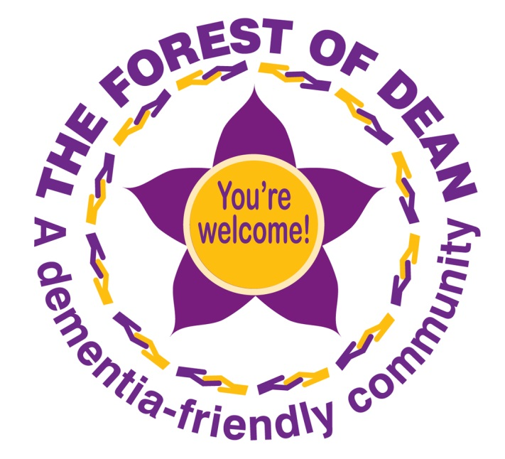
Thank you very much for joining The Forest of Dean Dementia Action Alliance.

is a member of….. 