Direct debit instruction
Please fill in this form to pay your council tax or business rates by direct debit and send it to:
Revenues Team, Council Offices, High Street, Coleford, Glos GL16 8HG[[
Applicant’s details
Name
Address
Contact telephone number

Name(s) of Account Holder(s)
Bank/Building Society Account Number
Branch Sort Code
Banks and Building Societies may not accept Direct Debit Instructions for some types of account.

Name and Full postal address of your Bank/Building Society

To: The Manager | Bank/Building Society
Address
Postcode

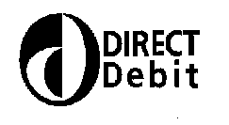

Instruction to your Bank
Or Building Society
To Pay By Direct Debit

Preferred Payment Date
1st | 15th | 22nd | 30th

Payments to January | Payments to March

Service User Number
9 | 7 | 3 | 1 | 0 | 4

Reference Number (bill number)

Instruction to your Bank or Building Society

Please pay Forest of Dean District Council Direct Debits from the account detailed in this instruction subject to the safeguards assured by the Direct Debit Guarantee. I understand that this instruction may remain with Forest of Dean District Council and, if so will be passed electronically to my Bank/Building Society.

Signature(s)
Date

-------------------------------------------------------------------------------------------------------------------------------------------------------------------------------------------------------------------
The Direct Debit Guarantee  (This Guarantee should be detached and retained by the payer) |  | 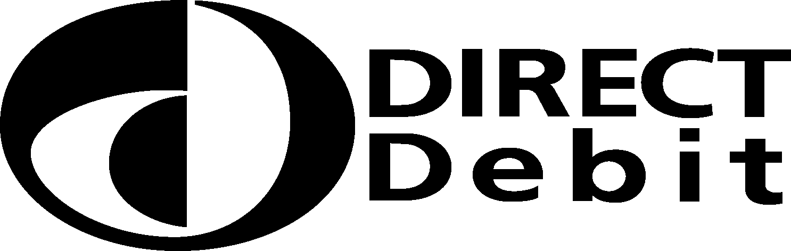
 | This Guarantee is offered by all banks and building societies that accept instructions to pay Direct Debits.
 | If there are any changes to the amount, date or frequency of your Direct Debit Forest of Dean District Council will notify you 10 working days in advance of your account being debited or as otherwise agreed. If you request Forest of Dean District Council to collect a payment, confirmation of the amount and date will be given to you at the time of the request.
 | If an error is made in the payment of your Direct Debit by Forest of Dean District Council or your bank or building society you are entitled to a full and immediate refund of the amount paid from your bank or building society
 | - If you receive a refund you are not entitled to, you must pay it back when Forest of Dean District Council asks you to
 | You can cancel a Direct Debit at any time by simply contacting your bank or building society. Written confirmation may be required. Please also notify us.

